
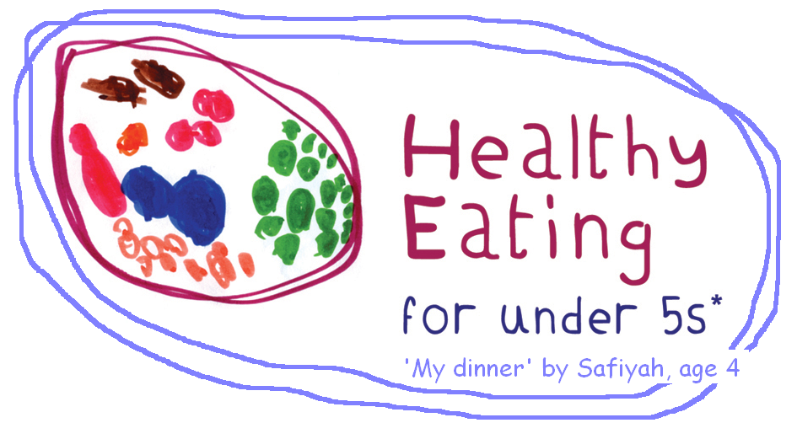
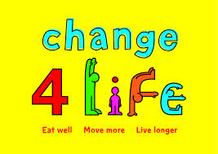
Healthy Eating for Under 5’s

FREE training for those working with children under 5 or their families e.g. childminders, children’s centre workers, nursery staff and drop in service staff.
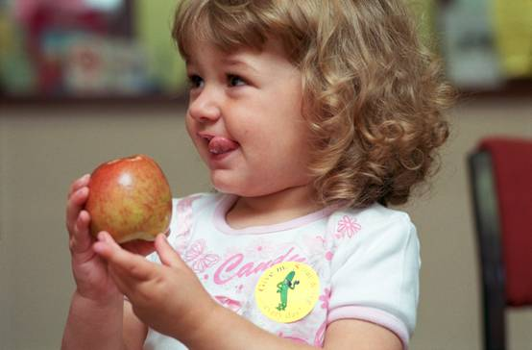


Learning objectives include the following:

- Understand why a healthy lifestyle is important for under 5’s
- Healthy Eating for under 5’s (including food portions, snacks vs treats, drinks, label reading)
- Fussy Eating and how to tackle it in your setting
- Be equipped to answer common questions from parents
- Know how to become a certified health promoting setting
    - Healthy Eating Awards
    - Awareness of local campaigns

When: Thursday 6th February 2014, 9am – 12.30pm
Where: The Isaac Newton Centre for CPD, 108 Lancaster Rd, London, W11 1QS

To book your places please contact:
Iman Hikal - Public Health Nutritionist
Iman.hikal@clch.nhs.uk
02073133020

