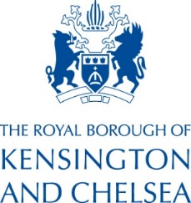
Membership of the Royal Borough’s SACRE – June 2026

Chair of the SACRE Laurence Julius
Clerk Natalija Sorokina, Business and Finance Officer (RBKC)
Local Authority Adviser Sophie Healey-Welch, Principal Lead Adviser (RBKC)
RE Adviser Angela Hill (RE Today)

GROUP A – up to 13 members
Representing Christian and other religious denominations, including non-religious worldview

Roman Catholics – 3 members
- Claire Bruce-Lamblin (Diocese of Westminster)
- 2 x Vacancies

Representatives of Christian Faiths outside the Church of England or Roman Catholic Church – 3 members
- Rev Ken Persaud (Notting Hill Community Church)
- 2 x Vacancies

Representatives of the Islamic Faith – 2 members
- Imran Asif (Discover Islam)
- Susan Jaff

Representatives of Other Non-Christian Faiths – 4 members
- Gillian Berg (Kensington and Chelsea Baha’i Community)
- Jo Backus (Network of Buddhist Organisations)
- Lady Singh (Kanwaljit Kaur) (Network of Sikh Organisations)
- Laurence Julius (Board of Deputies of British Jews / Spanish and Portuguese Synagogue, Holland Park)

Representative of Non-religious Worldview – 1 member
- Verity Richardson (Humanists UK)

Group B – up to 8 members
Representing the Church of England

Katrina Quinton – Diocese of London
Sarah Webber – London Diocesan Board of Schools
6 x Vacancies

Group C – up to 8 members
Representing teachers (including teachers of RE) and teachers’ associations

Celia Platt NEU
Yusra Omar NEU
Christian Kendall-Daw ASCL
5 x Vacancies

Group D – up to 4 members
Representing the Royal Borough

Cllr Catherine Faulks
3 x Vacancies

