Access to the childcare service can be found here - https://childcare-support.tax.service.gov.uk/
To get into their account, parents should click “”4. Apply or sign in to the childcare service as a parent”. They’ll then see this screen:
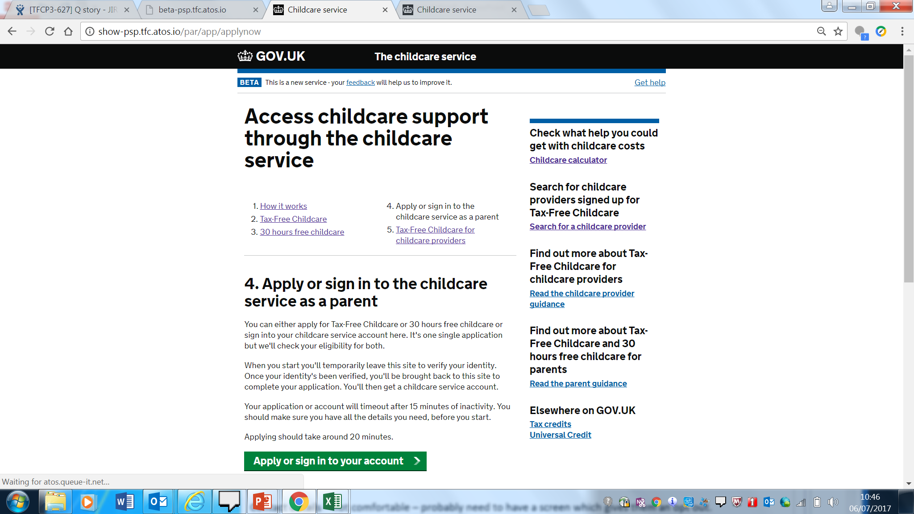

Parents can click “apply” and then will answer questions about their youngest child’s age before being asked to sign in using their Government Gateway ID, which they will have received when they applied.
Once they’ve signed in using Government Gateway, they will then see the childcare account screen:
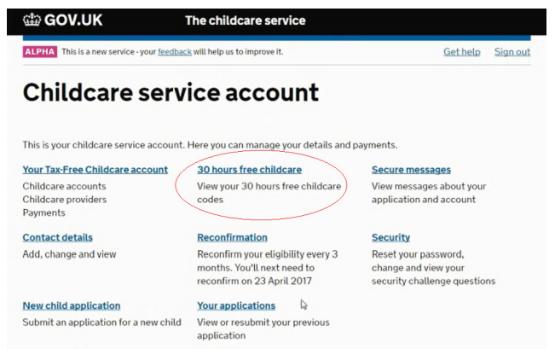

They can click on “30 hours free childcare” to see their 30 hours eligibility code. These normally start with “500”.
They will also find this code in their “secure messages”. An example secure eligibility message looks like this (this would be populated with the information of a real parent.
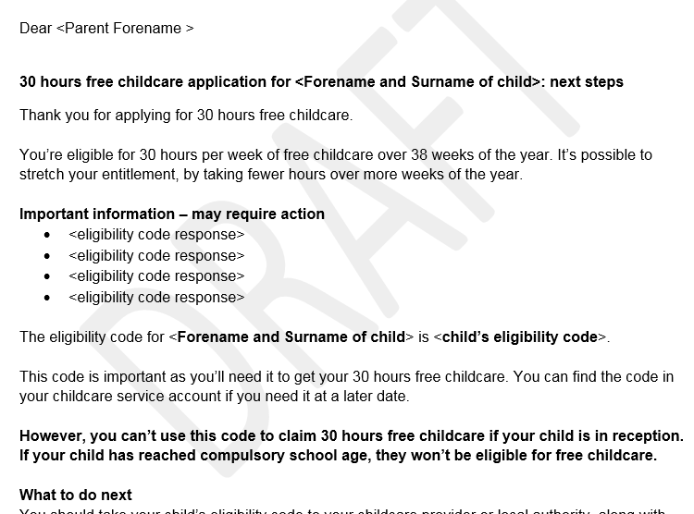

There may be a small number of parents who have a temporary code, starting “11…” They will have been given this over the phone, and will receive a letter containing this from HMRC too.
If any parents are still struggling to access their account, please contact the Customer Interaction Centre on 0300 123 4097.

