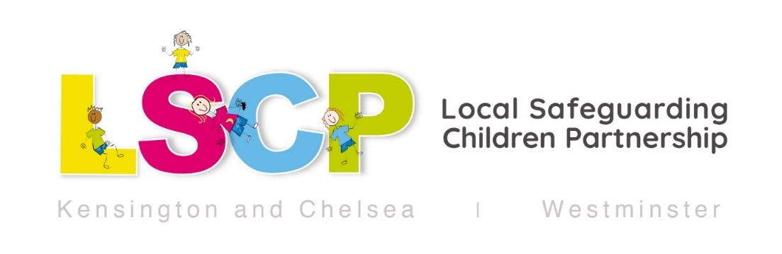

FGM Awareness Summer 2025

What is FGM?
Female Genital Mutilation (FGM) includes all procedures that intentionally alter or cause injury to the female genital organs for non-medical reasons.
This can include cutting, pricking, piercing, tattooing, stretching, sewing up and removal of any external genitalia.

The procedure, which some communities refer to as female circumcision or cutting has no health benefits for women or children. It is carried out for cultural and social reasons and it is always harmful.

FGM is a harmful practice that is not required by any religion. FGM is a form of child abuse with long-lasting harmful consequences and is illegal in UK.
We know that preventing FGM is the best form of protection for women and girls so raising awareness, learning more about it and being alert to the potential signs and indicators of vulnerability are all very important.

Why are the summer holidays important?
Studies show that girls are at more risk of FGM being carried out during the summer holidays, as this allows more time for them to ‘heal’ before they return to school.
Whilst some families might take their daughters abroad for this, the procedure may also take place in the UK.
Families may also come under pressure from relatives or friends in the UK or home country to have their daughters cut.

This summer, we are asking all staff in all agencies to be alert to the possible signs and indicators that girls may be at risk of FGM. This is a safeguarding issue that requires a prompt but sensitive approach and can raise anxiety in professionals. Please do not hesitate to contact Children’s Services (in the borough where the child lives) if you do have any concerns and need advice and guidance.
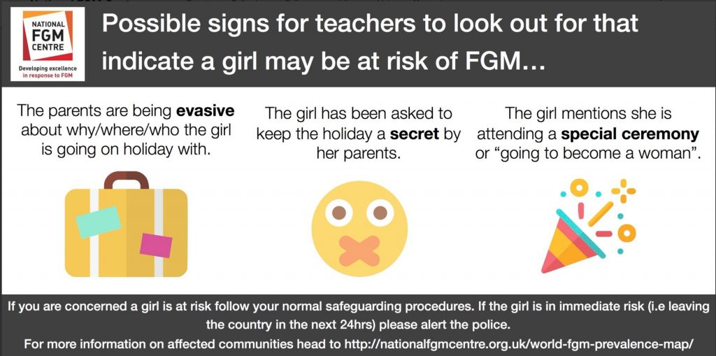

What are the potential signs that a girl could be at risk of FGM?
- A girl is born to a woman who has undergone FGM
- Mother has requested re-infibulation following childbirth
- A girl has an older sibling or cousin who has undergone FGM
- One or both parents or elder family members consider FGM integral to their cultural or religious identity
- The family indicate that there are strong levels of influence held by pro-FGM elders who are involved in bringing up female children

- A girl/family has limited level of integration within UK community
- A girl from a practising community is withdrawn from PSHE and/or Sex and Relationship Education or its equivalent may be at risk as a result of her parents wishing to keep her uninformed about her body, FGM and her rights
- If there are references to FGM in conversation, for example a girl may tell other children about it
- A girl may confide that she is to have a ‘special procedure’ or to attend a special occasion to ‘become a woman’
- A girl may request help from a teacher or another adult if she is aware or suspects that she is at immediate risk
- Parents state that they or a relative will take the child out of the country for a prolonged period and are evasive about why
- A girl is taken abroad to a country with high prevalence of FGM, especially during the summer holidays which is known as the ‘cutting season’

(National FGM Centre)

FGM Mandatory Reporting Duty (if FGM has taken place):
We would also like to remind practitioners working in certain settings about the FGM Mandatory Reporting duty.
It requires regulated health and social care professionals and teachers to report to the police cases of FGM in girls under 18 if, in the course of their professional duties, they see signs or symptoms indicating that a girl has undergone FGM or if she tells the professional that she has undergone it. Complying with the duty does not breach any confidentiality requirement or other restriction on disclosure which might otherwise apply.

Whilst all staff in children’s settings should speak to the designated safeguarding lead (DSL) or deputy with regard to any concerns about female genital mutilation (FGM), there is a specific legal duty on teachers and healthcare practitioners. If a teacher, or healthcare practitioner in the course of their work in the profession, discovers that an act of FGM appears to have been carried out on a girl under the age of 18, the teacher must report this to the police via Tel 101.
They should also continue to follow their usual safeguarding children procedures and ensure that a referral to Children’s Social Care in the borough where the child lives is made (Teachers should see Annex B of Keeping Children Safe in Education 2024 for further details).

Further practice guidance on FGM:

- London Safeguarding Children Procedures

- Harmful Practices Contact Guide 2025 Hammersmith and Fulham, Kensington and Westminster

- Female genital mutilation: resource pack
Updated February 2023

- Keeping Children Safe in Education 2024

- FACTSHEET FEMALE GENITAL MUTILATION

- National FGM Centre

- National FGM Centre: Female Genital Mutilation: Guidance for Schools (2019)
- Understanding your role in safeguarding girls, engaging parents and teaching about FGM

- National FGM Centre Good Referral Guide for FGM

- Multi-agency guidance on female genital mutilation

