Lrgo Based T
Lego Based Therapy

[Grab your reader’s attention with a great quote from the document or use this space to emphasize a key point. To place this text box anywhere on the page, just drag it.]
Language used in Lego Base Therapy:
Adjectives: Colour, shape, size, number of dots, height

Prepositions: In, on, under, next, in-between, in-front, behind

What is Lego Based Therapy?
Lego Based Therapy is an evidenced based intervention designed to support children with Autism with their social communication and language needs.

How do you carry our Lego Based Therapy?
In Lego Based Therapy, there are three job roles equally as important in the creation of the Lego.
- Builder - the person who listens and follows the instructions in order to build the object.
- Supplier - the person is responsible for bricks and listens to the engineer in order to find the correct bricks to give to the builder.
- Engineer - the person who is responsible for giving the instructions. They look at the Lego pictures and describe what needs to be completed.

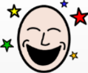
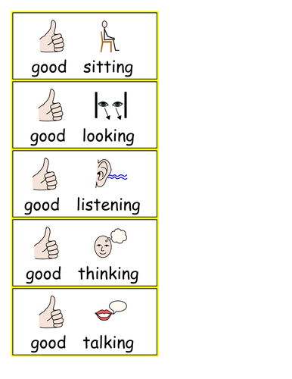
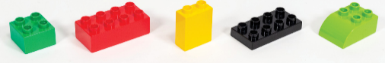
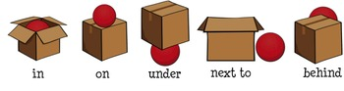
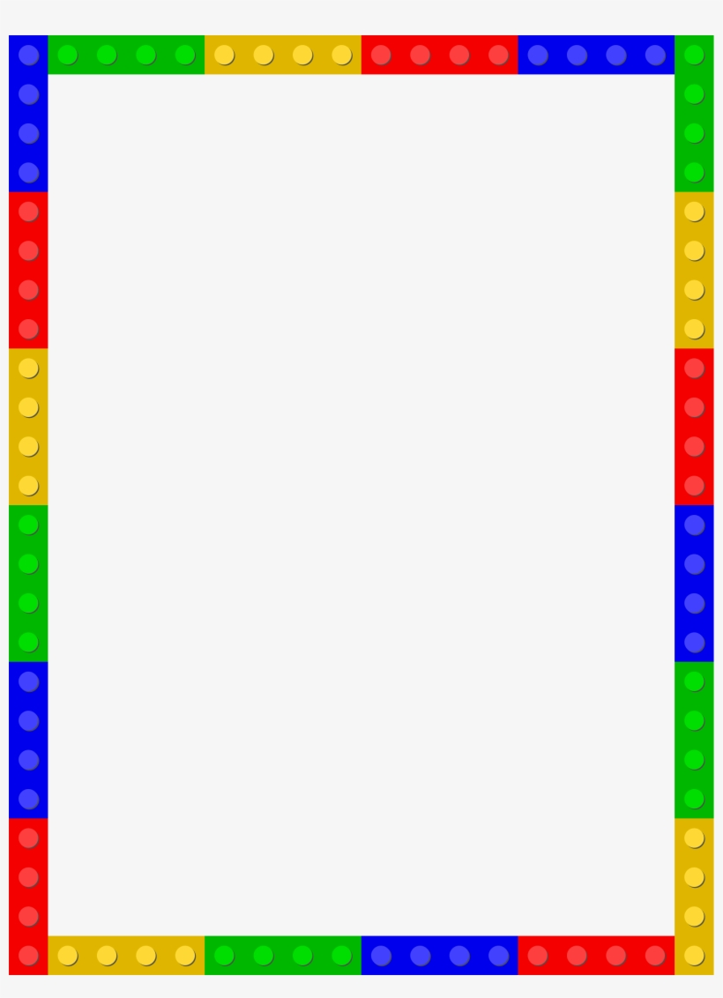
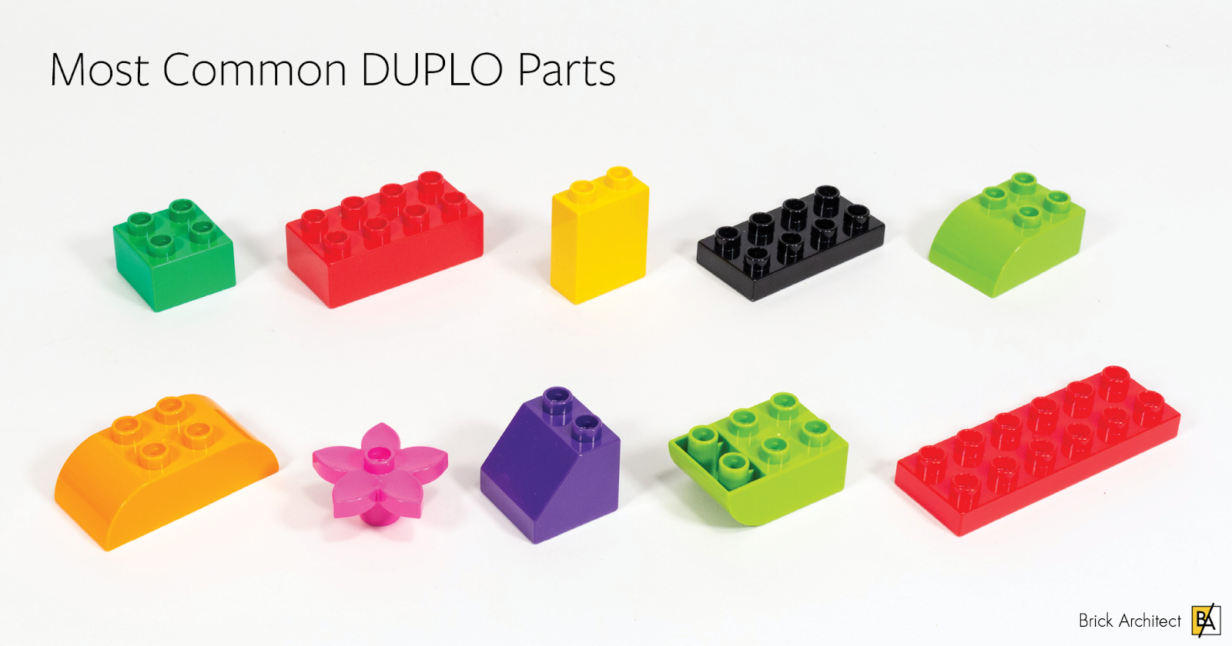
Have Fun

Benefits of Lego Based Therapy:
- Turn-taking
- Sharing
- Self-esteem
- Cooperation
- Listening skills
- Using names
- Following rules
- Problem solving
- Expressive language
- Receptive language
Have Fun

Expectations:

For further information, please contact:

Autism Advisory Service: AEYIT@rbkc.gov.uk

The Orchard, Hallfield School -

