Now and Next Board
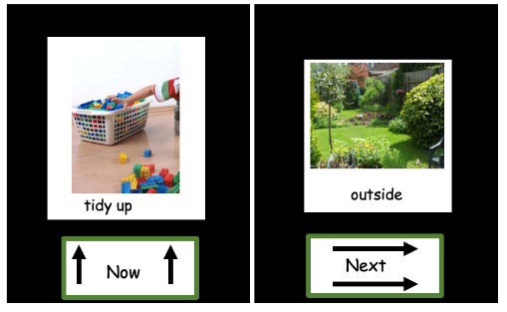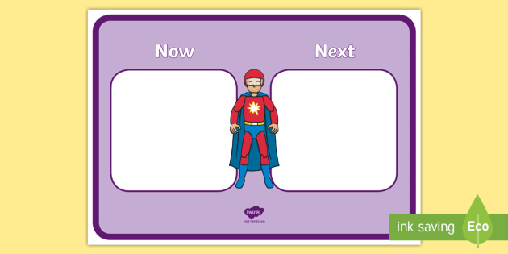
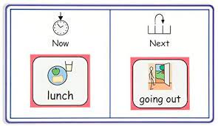
What is a Now and Next (First / Next) board?
- It is a visual strategy to help children understand and complete desired tasks. It is a great strategy than can help children who find instructions trick
- The board has the words 'Now' on the left-hand side and 'Next' on the right-hand side, with a space above to add a symbol or photograph
- The idea is that you put a picture/symbol or write the task that needs to be done in the 'now' box, and a motivating activity in the 'next' box
- A Now & Next board can help give the day some structure, letting a child know what will be happening next. It can also help them to become more motivated to do an activity given to them; by showing them that something they enjoy will be coming next
- It is important to use reduced language e.g. - “John, breakfast first; then play” When the first activity has finished you can say - “Breakfast finished (take the symbol off the board), next it is play” (point to the play symbol)
- Encourage the child to take the pictures off the Now side – and put it into a ‘Finished’ pocket or box – this gives clarity, and the child knows that the activity is finished
- REMEMBER – never put the picture from the ‘Next’ side onto the ‘Now’ side – with a new activity on the ‘Next’ side. Why would you want to finish your motivating activity to start something you do not really like?

