Stories for social understanding

What are they?

Social stories were developed by Carol Gray (1994) for use with children with Autism.

A social story is a short story written in a specific style and format, which

- describes what happens in a specific social situation.
- It describes what is obvious to most of us, but not to those with impaired social understanding.
- It describes what people do, why they do it and what the common responses might be

How do they help?

An autistic person may:

- require support to know how others are thinking or feeling
- have difficulties understanding social situations which means they need expectations clearly explained to them
- not know how to change the behaviour to suit the situation
- have rigid thoughts so they need support to think of other ways to resolve a situation or behave appropriately.

What to write?

- The child’s need determines the topic of the story
- The child’s perspective determines the focus of the story

When to read them?

- Read them in a quiet and calm place
- Have a range of people read the story with them
- Introduce the story with a simple straight forward approach
- Before they take part in the activity or situation that the story is written about

Example story

Lining up
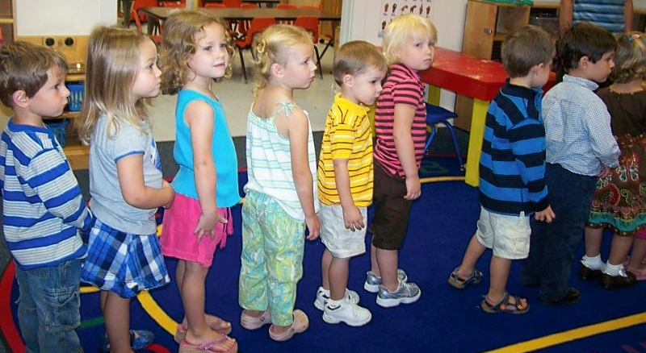
My name is Josh.
I am 5 years old, and I go to school.
In school, children sometimes need to line up with their class. Then they are ready to move safely from one place to another place.
I am learning to line up with the rest of the children.
All the children have a number. My number is 3. Ali is number 2. When the teacher tells us to line up, I will try to remember to stand behind Ali. I will try to walk behind Ali when we are moving around the school.
I am learning to line up.

Basic social stories use two kinds of sentences:
Descriptive sentences give accurate information about the setting. They provide the basic facts about what can be seen.

Coaching sentences gently guide behaviour via:
- Descriptions of effective child responses
- Descriptions of effective responses from supporting adults [Team]
- Self-coaching sentences: a script for the child to use

