Workstation

A workstation is part of the TEACCH approach and focuses on a child’s strengths to enable them to develop independent learning skills, support weaknesses and to reduce stress.

The workstation incorporates structure, routine, visual cues, and limits distraction, to develop independence, organisational skills, the concept of finished and the generalisation of skills.

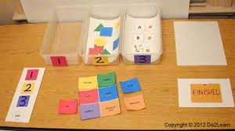

Set up a quiet, low distraction area for workstation and teaching activities. A table facing away from the room with a bookcase or cupboard to provide some screening can help. If the same area is used for 1:1 teaching and workstation activities, make sure the pupil knows which he/she will be doing.

A workstation will show the pupil
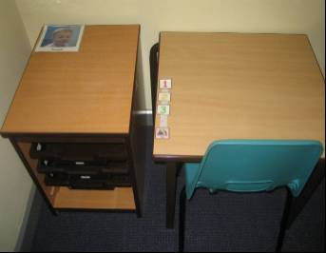

- What to do (using visual /structural cues e.g. a photo of the completed activity)
- How much work to do
- When the pupil will be finished
- What happens next
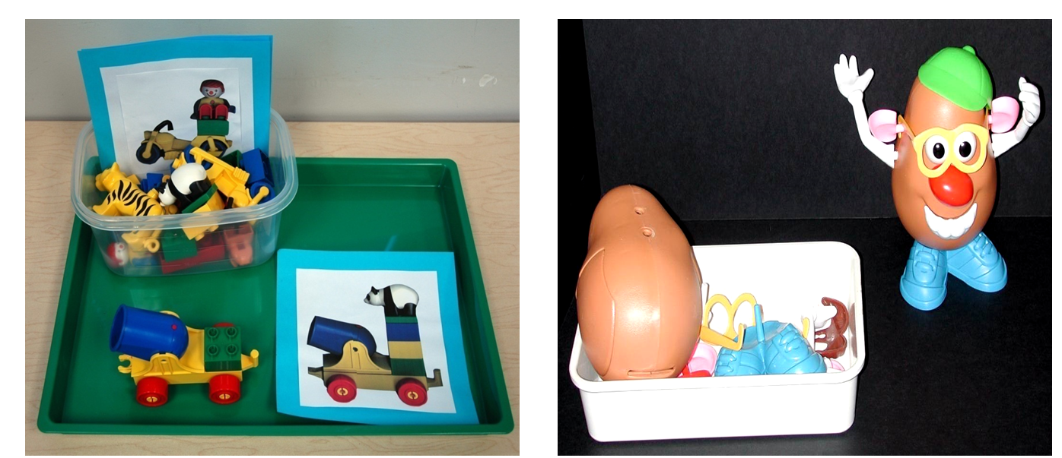
Workstation Structure

- Trays or folders containing activities are placed in drawers or stacked on a shelf/table on pupil’s left side. They are arranged top to bottom. They are numbered or have colour squares to match numbers /colour squares on a strip on tabletop. Velcro is very useful for attaching numbers.

- Child removes top number/colour square from strip and matches to corresponding tray/folder – attach to piece of Velcro on tray/folder.

- Child completes activity and then places tray to box or floor on right side, or back into tray storage system, if using.

- Repeat with following drawers/folders

- Once all numbers/colour squares have been removed from strip on tabletop and activities have been completed, the pupil has finished. A symbol at the bottom of the strip directs them to the next activity or their timetable.

- Some workstations may have a ‘reward’ tray or activity when the pupil has finished. if he/she needs this level of motivation to complete his/her work.

