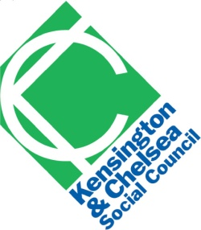
Mary Gardiner
KCSC
Lighthouse
111-117 Lancaster Road
London
W11 1QT

Mr Patrick Whitehead
Inspector
Royal Borough of Kensington & Chelsea Core Strategy EiP

18th June 2010

Dear Mr Whitehead,

Comments on draft programme and draft matters and issues

We would like to request the opportunity to take part in Hearing 4, Matter 7 & 8 on which we have made representations.

We confirm that we would like to take part at Hearing 1 Matter 1; Hearing 2 Matters 3 & 4; Hearing 3 Matters 5 & 6; Hearing 5 Matter 10 (already allocated).

We would like to request that procedural compliance is included as an issue to be examined under Matter 1. In particular whether public consultation was undertaken in accordance with the statutory requirements and the Statement of Community Involvement, and whether the Core Strategy is aligned and co-ordinated adequately with the Community Strategy.

Our reasons are two-fold. Firstly, representors Robin Melzer and Malcolm Souch, have raised concerns about these in their submissions and should have the opportunity to discuss these essential points at the hearing sessions. Secondly, the hearings should consider any other matters, irrespective of whether any representations have been made, which could indicate that the Core Strategy is unsound. The procedural questions put to the Council at the pre-hearing meeting go to the heart of the Plan's soundness and there should be the opportunity for all participants to comment on the Council's answers as part of the hearing sessions.

We would also like to request that the following questions are included:

Under Matter 8
“Are the policies sufficiently locally distinctive? Should there be stronger reference to the need for better public transport links in the north of the borough?”

Reasons: Our representation refers to poor public transport leading to the isolation of areas in the north of the borough such as Kensal.

Under Matter 10
“Would the policy benefit from reference to the Access Design Guide?”

Reasons: In our representation, we refer to the need for an access statement to underpin the focus on adaptability and lifetime homes. We are now aware that there is an Access Design Guide as part of the LDF, and this should be referred to in the Core Strategy. Making sure that housing (and everything else) is accessible is an important objective which should be tested. Our representation also refers to the importance of access for disabled people regarding voluntary and community sector premises.

Yours sincerely,

Mary Gardiner

